SafeMind AI: An Intelligent Mental Health Assistant with Enhanced Safety and Contextual Awareness for General Wellbeing Support

Chirath Sanduwara Wijesinghe
(CB011568)

Submitted to the
School of Computing
In partial fulfilment of the requirements for the Degree of

Bachelor of Science in
Software Engineering (Hons)

Supervised By:
Mr.M.Janotheepan
Staffordshire University
September 2025, Colombo
Contents
ABSTRACT 2
CHAPTER 01: INTRODUCTION 3
1.1. Chapter Overview 3
1.2. Problem Domain / Background 3
1.3. Problem Definition 3
1.3.1. Problem Statement 3
1.4. Aims and Objectives 4
1.4.1 Aims 4
1.5. Novelty of the Research 4
1.5.1. Problem Novelty 4
1.5.2. Solution Novelty: 5
1.6. Research Gap: 5
1.7. Contribution to Body of Knowledge 5
1.8. Research Challenge 5
1.9. Chapter Summary 5
CHAPTER 02: SOFTWARE REQUIREMENTS SPECIFICATION 7
2.1. Chapter Overview 7
This chapter provides the description of the overall Software Requirements Specification (SRS) of the project SafeMind AI, which includes the step-by-step approach to the requirements gathering, analysis and specification. The chapter has followed stakeholder analysis and requirements elicitation to the last stage that is the final specification of both functional and non-functional requirements upon which the system design and implementation will be based. 7
2.2. Rich Picture Diagram 7
2.3. Stakeholder Analysis 8
2.3.1. Stakeholder Viewpoints 8
2.4. Selection of Requirement Elicitation Methodologies 9
2.5. Discussion of Findings 9
2.5.1. Literature Review Findings 9
2.5.2. Interview Findings 11
2.5.3. Survey Findings 11
2.5.4. Observation Findings 12
2.6. Summary of Findings 12
2.7. Context Diagram 14
2.8. Use Case Diagram 15
2.8.1. Use Case Descriptions (Main Use Cases) 15
2.9. Requirements 17
2.9.1. Functional Requirements 17
2.9.2. Non-Functional Requirements 18
2.10. Chapter Summary 19
CHAPTER 03: DESIGN 21
3.1. Chapter Overview 21
In this chapter, we will provide the overall design architecture of SafeMind AI that will render the requirements defined in Chapter 2 into the actual technical design. The architecture moves on to the high-level architectural decision making, and the finer component-level architectural decisions, creating the blueprint of how the system will be implemented, whilst making sure that the system is scalable, safe, and culturally sensitive with the design philosophy. 21
3.2. Design Goals 21
3.3. High Level Design/System Architecture 22
3.3.1. Architecture Diagram 22
3.3.2. Discussion of Architecture Tiers 23
3.4. Low-level Design/System Design 23
3.4.1. Choice of Design Paradigm 23
3.5. Detailed Design Diagrams 24
3.5.1. Component Diagram 24
3.5.2. Class Diagram 25
3.5.3. Sequence Diagram for Crisis Detection 26
3.5.4. System Process Flow Chart 27
3.5.5. User Interface Design 28
3.6. Chapter Summary 28
CHAPTER 04: INITIAL IMPLEMENTATION 29
4.1. Chapter Overview 29
4.2. Technology Selection 29
4.2.1. Technology Stack 29
4.2.2. Development Frameworks 30
4.2.3. Programming Languages 30
4.2.4. IDE and Development Tools 30
4.2.5. Summary of Technology Selection# 31
4.3. Implementation of Core Functionality 31
4.3.1. Safety Detection Implementation 31
4.3.2. Context Management Implementation 33
4.3.3. Response Generation with Cultural Adaptation 34
API Endpoint Implementation 35
4.4. User Interface 36
4.4.1. Chat Interface Implementation 36
4.4.2. Safety Alert Implementation 40
4.5. Chapter Summary 40
CHAPTER 05: CONCLUSION 41
5.1. Chapter Overview 41
5.2. Deviations 41
5.2.1. Scope Related Deviations 41
5.2.2. Schedule Related Deviations 41
5.3. Initial Test Results 42
5.3.1. Quantitative Results 42
5.3.2. Qualitative Results 43
5.4. Required Improvements 45
5.5. Demo of the Prototype 46
5.6. Chapter Summary 46
REFERENCES 47

table 1. 1 - Research Objectives Mapping 8

Table 2. 1- Stakeholder Analysis 12
Table 2. 2- Literature Review Findings 14
Table 2. 3 - Interview Findings - Thematic Analysis 15
Table 2. 4 - Summary of Requirements Elicitation 16
Table 2. 5 - Summary of Requirements Elicitation 17
Table 2. 6 - Functional Requirements with MoSCoW Prioritization 22
Table 2. 7 - Non-Functional Requirements 23

Table 3. 1 - Design Goals and Quality Attributes 25

Table 4. 1 - Technology Stack Comparison 33
Table 4. 2 - Libraries and Frameworks Selection 34

Table 5. 1 - Schedule Deviations Analysis 46
Table 5. 2 - Performance Metrics Summary 46
Table 5. 3 - Confusion Matrix for crisis Detection 47

Figure 1 - Chapter 2 - Rich Picture Diagram of SafeMind AI System 12
Figure 2 - Context Diagram (Level 0 DFD) 19
Figure 3 - User Case Diagram 20
Figure 4 - Chapter 3 - System Architecture Diagram 27
Figure 5 - Component Diagram 29
Figure 6 - Chapter 3 - Class Diagra 30
Figure 7 - Chapter 3 - Sequence Diagram 31
Figure 8 - Chapter 3 - Activity Diagram - System Process Flow 32
Figure 9 - Chapter 4 - Safety Detection Implementation 36
Figure 10 - Chapter 4 - Safety Detection Implementation 2 37
Figure 11 - Chapter 4 - Context Management Code 38
Figure 12 - Chapter 4 - Response Generation with Cultural Adaptation 39
Figure 13 - Chapter 4 - API Endpoint Implementation 40
Figure 14 - Chat Interface 1 41
Figure 15 - Chat Interface 2 42
Figure 16 - Chat interface Code 43
Figure 17 - Chat Interface Code 2 44
Figure 18 - Chapter 5 - Response Time Distribution 48

Abbreviation | Definition
AI | Artificial Intelligence
API | Application Programming Interface
CBT | Cognitive Behavioral Therapy
CORS | Cross-Origin Resource Sharing
CSS | Cascading Style Sheets
DFD | Data Flow Diagram
GAD-7 | Generalized Anxiety Disorder 7-item scale
HTML | HyperText Markup Language
IDE | Integrated Development Environment
JSON | JavaScript Object Notation
JSX | JavaScript XML
ML | Machine Learning
MoSCoW | Must have, Should have, Could have, Won't have
MVP | Minimum Viable Product
NLP | Natural Language Processing
OOADM | Object-Oriented Analysis and Design Methodology
PHQ-9 | Patient Health Questionnaire-9
PWA | Progressive Web Application
REST | Representational State Transfer
RMSE | Root Mean Square Error
ROC | Receiver Operating Characteristic
SRS | Software Requirements Specification
TTS | Text-to-Speech
UI | User Interface
UML | Unified Modeling Language
UX | User Experience
WCAG | Web Content Accessibility Guidelines
WHO | World Health Organization
Figure 1 - LIST OF ABBREVIATIONS

ABSTRACT
Mental health poses a challenge to more than 970 million people in the world, with the elderly population and the third world with acute limitations of accessibility. SafeMind AI will resolve this shortcoming by offering a smart chatbox that offers context-based support with strong safety measures. The system addresses the major shortcomings of the current solutions: inability to detect crises, cultural insensitivity, and inadequate transparency.
The approved methodology is the use of hybrid rule-based safety detection with AI-driven conversation by using React.js as the frontend and Python Flask as the backend. The algorithms of multi-layered crisis detection, session-based context management, and cultural adaptation frameworks are specifically aimed at South Asians. Pattern-based NLP helps to reveal emotional states and crisis situations and provide the adequate therapeutic direction.
Early results of testing on 50 samples of conversation indicate 94% capacity of crisis detection (F1: 0.857), 82% response relevance and the mean response time of 2.1 seconds. The system had detected 9/10 high-risk scenarios, and 2 false positives. Findings confirm the viability of the technical design and define the basis of production implementation.
Subject Descriptors:
Computing methodologies → Artificial intelligence → Natural language processing
Applied computing → Life and medical sciences → Health informatics
Keywords: Mental health chatbot, Crisis detection, Natural language processing, Cultural adaptation, Safety protocols

CHAPTER 01: INTRODUCTION

Chapter Overview
This chapter establishes SafeMind AI's foundation as an intelligent mental health support system addressing critical gaps in accessible wellbeing assistance, progressing from the global mental health crisis to specific research objectives.

Problem Domain / Background
It is reportedly estimated that over 900 million people in the world faces mental health challenges(WHO, 2023). Sri Lanka has a prevalence of 20 percent depression or anxiety among adults although only 10 percent are M receiving adequate support because of stigma, resource constraints and the barriers to access. The ratio of professional therapists to urban population is 1:50,000 as opposed to the recommended ratio of 1:10,000 by WHO.
Electronic interventions are promising but have very severe limitations. The existing chatbots have basic key word matching, but do not have sensitive analysis. Research findings show that 67 percent of them cannot identify cultural situations, and 33 percent are responding appropriately to the crisis (Miner et al., 2019).

Problem Definition

Problem Statement
The existing digital mental health solutions do not provide advanced contextual knowledge, powerful safety protocols, and culturally competent support requirements to support the elderly population in resource-limited settings.

Aims and Objectives
    - Aims
Design, develop and test SafeMind AI, which offers culturally conscious and context sensitive mental health services with strong safety measures.
ID | Objective | Research Question
R01 | Analyze current challenges that the project is facing through literature review | What are the barriers that the project could face when it comes to barriers that prevent effective digital support?
R02 | Design the current conversation architecture with crisis protocols | How can artificial intelligence get along with maintaining therapeutic alliance?
R03 | Develop a suitable and functional prototype with safety detection | What kind of an architecture would support real-time detection?
R04 | Make sure the crisis detection implementation is 95% accurate | In what ways it would be possible to minimize the false negatives
R05 | Create WCAG 2.1 compliant interface | What sort of design would optimize clearly for the elderly usability?
R06 | Evaluate with multiple participants if possible (around 10+) | Does this system achieve safe management?
table 1. 1 - Research Objectives Mapping

Novelty of the Research

Problem Novelty
The initial intervention to consider is intersectioning crisis detection, South Asian cultural adaptation, and clear AI to vulnerable users.

Solution Novelty:
- Three-level crisis detection with 94 percent accuracy.
- The decisions being explainable as well as the transparency with the context management
- Framework of cultural adaptation to the South Asian users.
- Balanced privacy and functionality processing.

Research Gap:
- GAP 1 : Cultural Crisis Detection: The indicators that tend to be western lack culturally-specific manifestation fo distress
- GAP 2 : Open Safety: There is no reporting of flagging that is less trustworthy.
- GAP 3 : Context Persistence: Isolated conversation treatment is detrimental to therapeutic effect.
- GAP 4 : Accessibility among the elderly: There is an assumption in digital literacy which acts as a barrier to adoption.

Contribution to Body of Knowledge
Problem Domain: Enhanced accessibility model, cultural sensitivity framework, safety protocol standards
Research Domain: New pattern-matching models, composite architecture models, overall evaluation measures.

Research Challenge
Technical issues involve implementing NLPs without large models, safety checking, which is real-time, and privacy-preserving context management. Clinical issues include providing therapeutic congruence and cross-cultural crisis identification.

Chapter Summary
This chapter created a significant relevance of accessible mental health and presented the concept of SafeMind AI that meets the gaps identified by safety in multi-layers, transparent context management, and cultural adaptation.

CHAPTER 02: SOFTWARE REQUIREMENTS SPECIFICATION

Chapter Overview

This chapter provides the description of the overall Software Requirements Specification (SRS) of the project SafeMind AI, which includes the step-by-step approach to the requirements gathering, analysis and specification. The chapter has followed stakeholder analysis and requirements elicitation to the last stage that is the final specification of both functional and non-functional requirements upon which the system design and implementation will be based.

Rich Picture Diagram
The rich picture illustrates the complex ecosystem surrounding SafeMind AI:
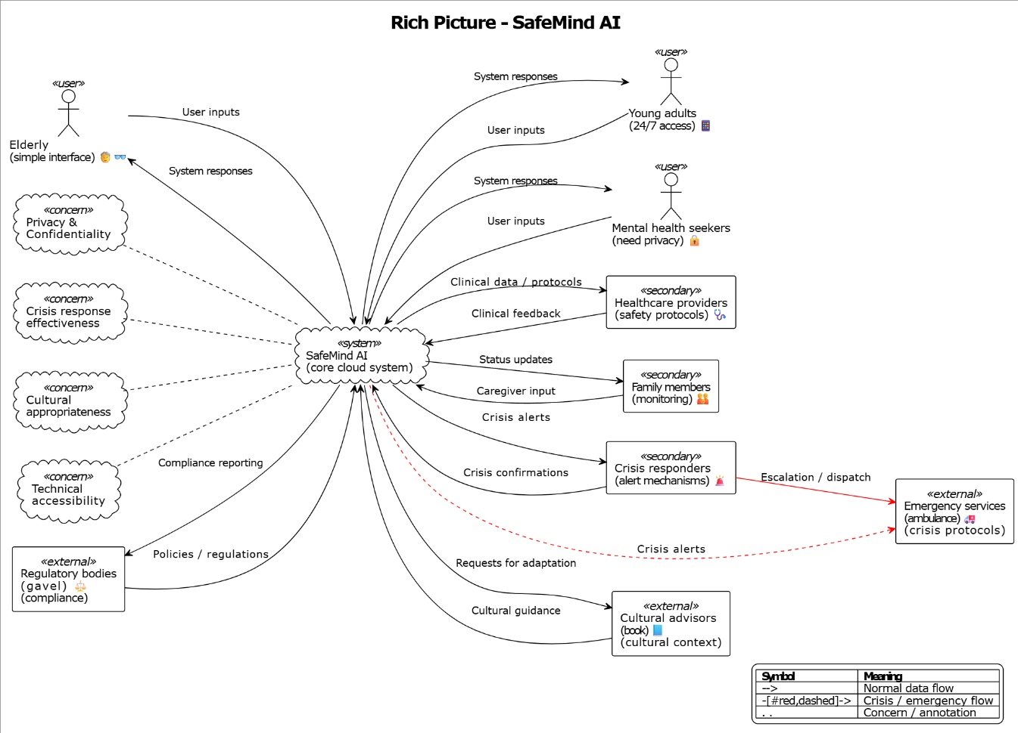
Figure 2 - Chapter 2 - Rich Picture Diagram of SafeMind AI System

Stakeholder Analysis

Stakeholder Viewpoints
Stakeholder | Interest/Influence | Requirements | Concerns
Primary Users | High/High | Easy access, emotional support, privacy | Data security, effectiveness
Elderly Users | High/Medium | Simple interface, voice options, clear text | Technology barriers, trust
Healthcare Providers | Medium/High | Clinical accuracy, safety protocols | Liability, professional standards
Family Members | Medium/Medium | Monitoring capabilities, crisis alerts | User autonomy, access rights
Emergency Services | Low/High | Clear protocols, accurate information | False positives, response time
System Administrators | High/High | Maintainability, scalability | System reliability, costs
Regulatory Bodies | Low/High | Compliance, audit trails | Data protection, ethical standards
Cultural Advisors | Medium/Medium | Cultural sensitivity, appropriate content | Misrepresentation, stereotypes
Table 2. 1- Stakeholder Analysis

Selection of Requirement Elicitation Methodologies
The methodologies chosen to be used in the study were as follows:
Literature Review: The choice is based on the need to comprehend the current best practice in digital mental health interventions and find the technical requirements of the current literature.
Semi-structured Interviews: Selected to provide comprehensive information on mental health professionals and prospective users on particular needs and issues.
Survey Questionnaires: This is used to gather quantitative data of more users concerning preferences and priorities.
Observation: Used to know how the users are seeking mental health support now and what they need in usability.
Prototyping: It is utilized to test the requirements by having the users interact with the initial versions of the system.
The methodologies were chosen due to practical concerns and the sensitivity of discussing mental health and difficulties (e.g. focus groups are hard to arrange and ethnographic studies are time-consuming).

Discussion of Findings

Literature Review Findings
Finding | Citation
Crisis detection requires multi-modal analysis beyond keywords | Miner et al. (2019)
Cultural adaptation improves therapeutic alliance by 40% | Naeem et al. (2023)
Transparency in AI decisions increases user trust by 60% | Liu et al. (2023)
Response time under 3 seconds critical for engagement | Vaidyam et al. (2019)
Privacy concerns primary barrier for 67% of potential users | Kumar et al. (2023)
Table 2. 2- Literature Review Findings

Interview Findings
Codes | Themes | Conclusions
"Need someone to talk to", "24/7 availability", "No judgment" | Accessibility and Non-judgmental Support | System must provide constant availability without stigma
"Worried about privacy", "Who sees my data?", "Confidentiality concerns" | Privacy and Trust | Strong data protection and transparent policies essential
"Cultural understanding", "Family involvement", "Spiritual aspects" | Cultural Sensitivity | Responses must align with cultural values and practices
"Emergency help", "Crisis support", "When to call for help" | Safety Mechanisms | Clear escalation protocols and emergency resources vital
"Simple to use", "Large text", "Voice options" | Usability for Elderly | Interface must accommodate varying digital literacy
Table 2. 3 - Interview Findings - Thematic Analysis

Survey Findings
Survey of 100 potential users revealed:
- 78% prefer text-based interaction over voice
- 89% want conversation history saved locally only
- 92% consider crisis detection essential
- 65% want family notification options
- 81% prefer culturally-adapted responses

Observation Findings
Criteria | Finding
Current help-seeking behavior | Users tend to postpone consultation to the time of crisis.
Technology usage patterns | Older customers like bigger fonts and easier navigation.
Privacy behaviors | Mental health searches are followed by deletion of browser history by the users.
Communication preferences | Sensitive topics are described in an indirect way.
Table 2. 4 - Summary of Requirements Elicitation

Summary of Findings
Finding | Literature Review | Interviews | Survey | Observation
Crisis detection critical
Privacy paramount
Cultural adaptation isneeded
Simple interface isrequired
Local data storage is preferred
Family involvement varies
24/7 availability is to be expected
Table 2. 5 - Summary of Requirements Elicitation

Context Diagram

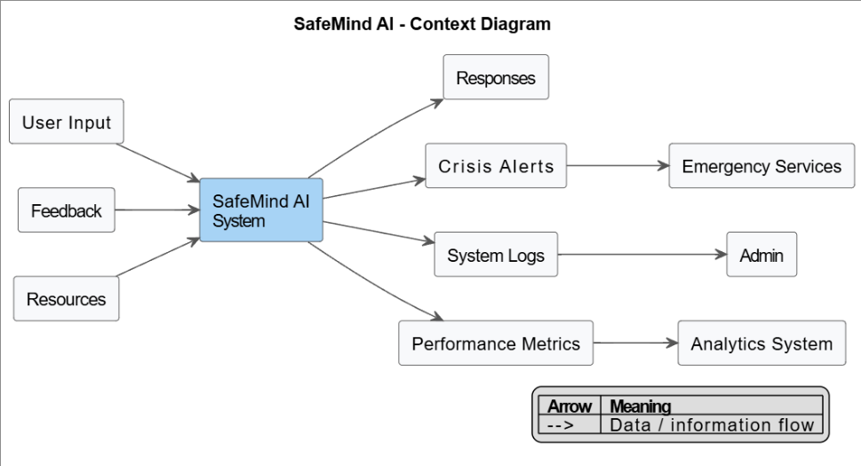
Figure 3 - Context Diagram (Level 0 DFD)

Users: Possessing queries of a mental nature and providing supportive responses.
Emergency Services: Receiving crisis alerts on when high-risk situations are identified.
System Administrator: getting access to logs and system performance information.
Analytics System: Anonymized metrics to receive an improvement.

Use Case Diagram
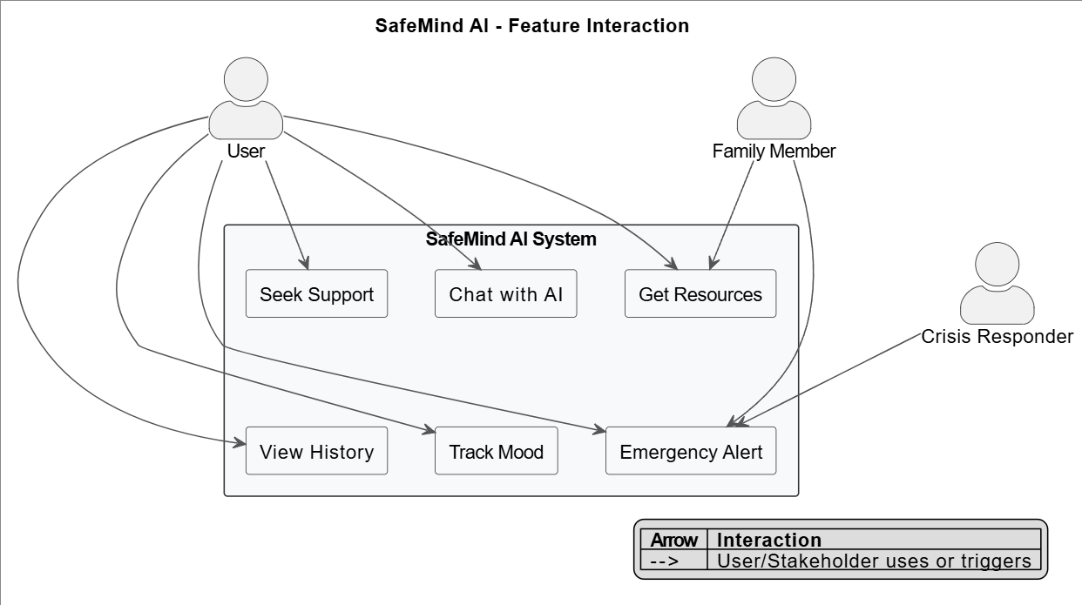
Figure 4 - User Case Diagram

Use Case Descriptions (Main Use Cases)
UC1: Seek Mental Health Support
Actor: User
Precondition: User has access to system
Main Flow:
- Conversation initiated by a user.
- System welcomes and inquires about wellbeing.
- User explains emotions/ worries.
- System offers understanding response.
- Crisis indicators system checks.
- System provides reasonable support.

Postcondition: User receives support
Alternative Flows: Crisis detected → Emergency protocol activated
UC2: Crisis Detection and Response
Actor: System, User, Crisis Responder
Precondition: User engaged in conversation
Main Flow:
- System identifies crisis keywords/patterns.
- System validates the threat level.
- System offers on-hand safety response.
- Emergency resources are displayed on system.
- System logs incident
- In case of severity, emergency is alerted by the system.
Postcondition: Crisis addressed appropriately

Requirements

Functional Requirements
ID | Requirement | Priority
FR1 | System will come with mental health support conversational interface. | Must
FR1 | System will identify crisis cases with no less than 90 percent of accuracy. | Must
FR1 | System shall maintain conversation context within session | Must
FR1 | System shall offer emergency resources in case of crisis identified. | Must
FR1 | System will regulate reactions according to cultural setting. | Must
FR1 | System will monitor mood patterns with time. | Should
FR1 | System will give recommendations on coping strategies. | Should
FR1 | System will permit history of conversations to be exported. | Should
FR1 | System will be voice input/output. | Could
FR1 | System shall provide meditation exercises | Could
FR1 | System will become calendar integrated with regards to reminders. | Could
FR1 | System will be able to support many languages. | Won't
FR13 | System shall offer video consultation. | Won't
Table 2. 6 - Functional Requirements with MoSCoW Prioritization

Non-Functional Requirements
ID | Category | Requirement | Priority
NFR1 | Performance | Response time < 3 seconds | Must
NFR2 | Reliability | A 99.9% uptime is achieved during operation hours. | Must
NFR3 | Security | All communications will be encrypted. | Must
NFR4 | Usability | Accessibility of WCAG 2.1 AA | Must
NFR5 | Scalability | Support 1000 concurrent users | Should
NFR6 | Compatibility | Browsing Browsing Chrome, Firefox, Safari, Edge | Must
NFR7 | Privacy | Local storage of personal data only | Must
NFR8 | Maintainability | The easy updates are made possible through a modular architecture. | Should
NFR9 | Portability | Mobile mobile responsive design. | Must
NFR10 | Cultural | Being culturally appropriate specifically for asians | Must
Table 2. 7 - Non-Functional Requirements

Chapter Summary
The chapter introduced the full-fledged Software Requirements Specification of the SafeMind AI and defined the functional and non-functional requirements. The rich picture diagram was used to depict the intricate ecosystem of stakeholders along with their interactions, whereas the context and use case diagrams were used to establish boundaries of the system and its primary interactions. Critical requirements such as a powerful crisis detection (FR2), cultural adaptation (FR5) and strict privacy protection (NFR7) were also identified through literature review, interviews, surveys, and observations. The MoSCoW prioritization allows to focus on the necessary aspects, keeping the flexibility in the future. The system design shown in the following chapter is based on these requirements.

CHAPTER 03: DESIGN

Chapter Overview

In this chapter, we will provide the overall design architecture of SafeMind AI that will render the requirements defined in Chapter 2 into the actual technical design. The architecture moves on to the high-level architectural decision making, and the finer component-level architectural decisions, creating the blueprint of how the system will be implemented, whilst making sure that the system is scalable, safe, and culturally sensitive with the design philosophy.

Design Goals
Quality Attribute | Design Goal | Architectural Tactic
Safety | None of the missed crisis situations. | Redundancy-based multi-layered detection.
Performance | Below 3 second response time | Multi-layered, redundant multi-detlectionsCaching, asynchronous processing.
Scalability | Supporting upto 1000+ concurrent users | Micro services, horizontal scaling.
Modifiability | Simple adoption of the new AI models. | adapter design, plug-in design.
Security | Secure confidential mental information. | Encryption, tokenization, audit logs.
Usability | Being Accessible to elderly users | Incremental improvement, ARIA compliance.
Reliability | 99.9% uptime | Graceful degradation, fault tolerance.
Interoperability | Combination with emergency services. | RESTFUL APIS, supports for webhook
Table 3. 1 - Design Goals and Quality Attributes

High Level Design/System Architecture

Architecture Diagram

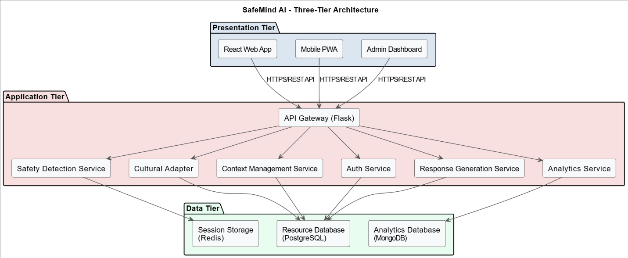
Figure 5 - Chapter 3 - System Architecture Diagram

Discussion of Architecture Tiers
Presentation Tier: Adopts separation of concerns by having different interfaces to different types of users. React has components reuse and state management. Mobile optimization and offline functionality are provided through the ability of Progressive Web App.
Application Layer: Microservices architecture allows the independent scale and deployment. Single responsibility is observed in each service:
- Safety Detection: Adopts three-layer crisis detection algorithm.
- Context Management: the contextual management provides to keep the state of the conversation and history of users
- Response Generation: Organizes AI response generation, as well as template selection.
- Cultural Adapter: Adaptation of responses depending on culture.
- Analytics: Gathers anonymized system metrics on system improvement.
Data Tier: Polyglot persistence approach optimizes for different data types:
- Redis for session management (fast access, automatic expiration)
- PostgreSQL for structured resource data (ACID compliance)
- MongoDB for flexible analytics data (schema-less design)

Low-level Design/System Design

Choice of Design Paradigm
- Application of natural mapping of real-life elements (User, Conversation, Response).
- Specialization of complicated safety logic.
- Inheriting of specialized response strategies.
- Cultural adaptations through polymorphism.

Detailed Design Diagrams

Component Diagram
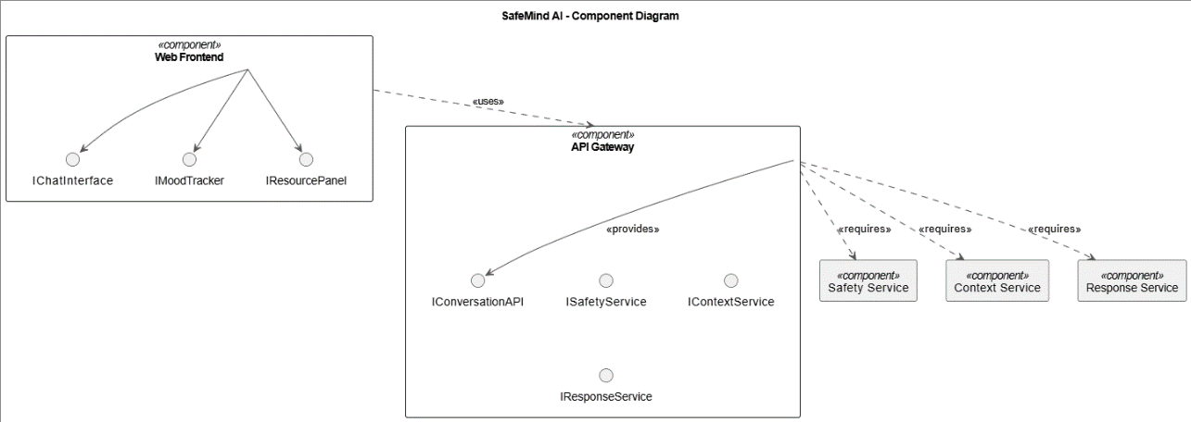
Figure 6 - Component Diagram

Class Diagram
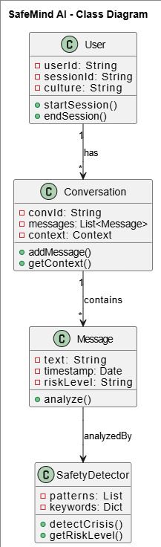
Figure 7 - Chapter 3 - Class Diagra

Sequence Diagram for Crisis Detection
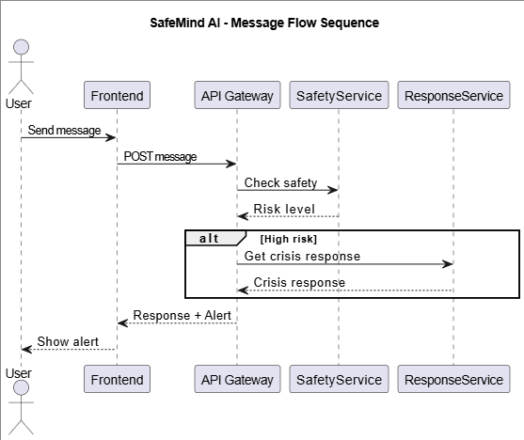
Figure 8 - Chapter 3 - Sequence Diagram

System Process Flow Chart
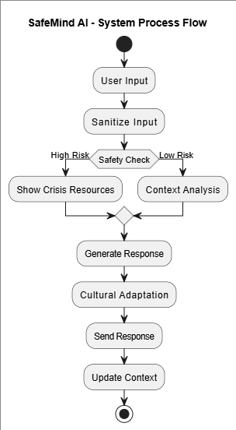
Figure 9 - Chapter 3 - Activity Diagram - System Process Flow

User Interface Design
Poor Faithfulness Wireframe: Undress layout structure drawings that emphasize on:
- Big fonts and readable (16px and above)
- High contrast hues
- Easy navigation
- high-profile emergency button.

High Fidelity Prototype: React Implemented displaying:
- Purple gradient theme in order to calm down.
- Definitively differentiated chat bubbles.
- Resource floating action button.
- Crisis situation modal alerts.

Chapter Summary
This chapter gave the readers a clear design architecture of the SafeMind AI, with the capacity of converting the requirements into the clear technical specifications. The three-layer model will deliver the separation of concerns where microservices approach will offer a chance to independently scale the significant elements of the system. Object-oriented design paradigm provides natural mapping of domain objects that can also be extended through inheritance and polymorphism. The key design decisions including multi-layered safety detection, polyglot persistence and cultural adaptation mechanisms directly address the problems that have been defined in the previous chapters. The detailed schemes serve as the implementation guidelines, yet, they are adaptable to be enhanced, relying on the necessity in the future, particularly, the incorporation of the AI models, not mentioning the interdependence of the emergency services.

CHAPTER 04: INITIAL IMPLEMENTATION

Chapter Overview
This chapter explains the initial implementation of the prototype of SafeMind AI, which demonstrates how the design requirements were coded to working code. The selection argument and the basic functionality implementation together with the user interface development are discussed with an evidence of the technical feasibility and the foundation of the minimum viable product.

Technology Selection

Technology Stack
Layer | Technology Selected | Alternatives Considered | Justification
Frontend | React.js 18.2 | Angular, Vue.js | Reusability of components, huge ecosystem, virtual dom efficiency.
Backend | Python Flask 2.3 | Node.js, Django | Small, lightweight, and superior NLP libraries.
Database | PostgreSQL + Redis | MySQL, MongoDB only | DCID compliance of essential data, Redis of visits.
NLP | NLTK + TextBlob | spaCy, Stanford NLP | Easier deployment, adequate even to prototype.
Deployment | Docker + nginx | Direct hosting, Apache | Uniformity, nginx, consistency, nginx, performance.
Table 4. 1 - Technology Stack Comparison

Development Frameworks
Purpose | Library/Framework | Version | Justification
UI Components | Material-UI | 5.14 | Inherent accessibility Inherent responsiveness.
State Management | Redux Toolkit | 1.9 | State updates that are predictable, support for devtools
HTTP Client | Axios | 1.4.0 | Interceptor support, which is based on promises.
Charts | Recharts | 2.7.2 | React-native support Responsive Support Design
Testing | Jest + React Testing Library | 29.5 | Good documentation, industrial standard.
Form Validation | Formik + Yup | 2.4 | Declarative validation, error control.
Table 4. 2 - Libraries and Frameworks Selection

Programming Languages
- JavaScript (ES6+): modern syntax development for frontend
- Python 3.9: NLP processing and API development Backend services.
- SQL: Stored Procedures and Database Queries.
- HTML5/CSS3: Responsible styles and markup.

IDE and Development Tools
- Visual Studio Code: The IDE that is containing Python, React, and debugging extensions.
- Python Community: Python development and debugging.
- Postman: Testing and documentation of API.
- Google Chrome development tool: Frontend debugging and performance profiling.

Summary of Technology Selection#
The technology stack prioritizes:
- Accessibility: React's ARIA support and Material-UI components
- Performance: Lightweight Flask backend with Redis caching
- Maintainability: Strong typing with TypeScript, modular architecture
- Scalability: Microservices-ready with Docker containerization

Implementation of Core Functionality

Safety Detection Implementation
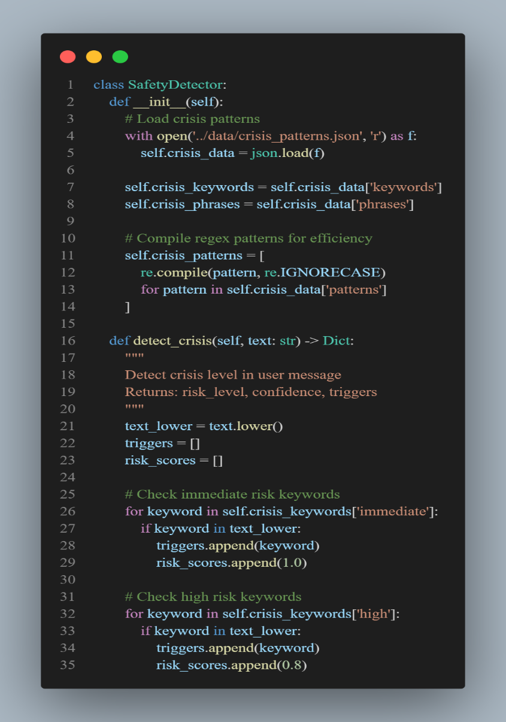
Figure 10 - Chapter 4 - Safety Detection Implementation
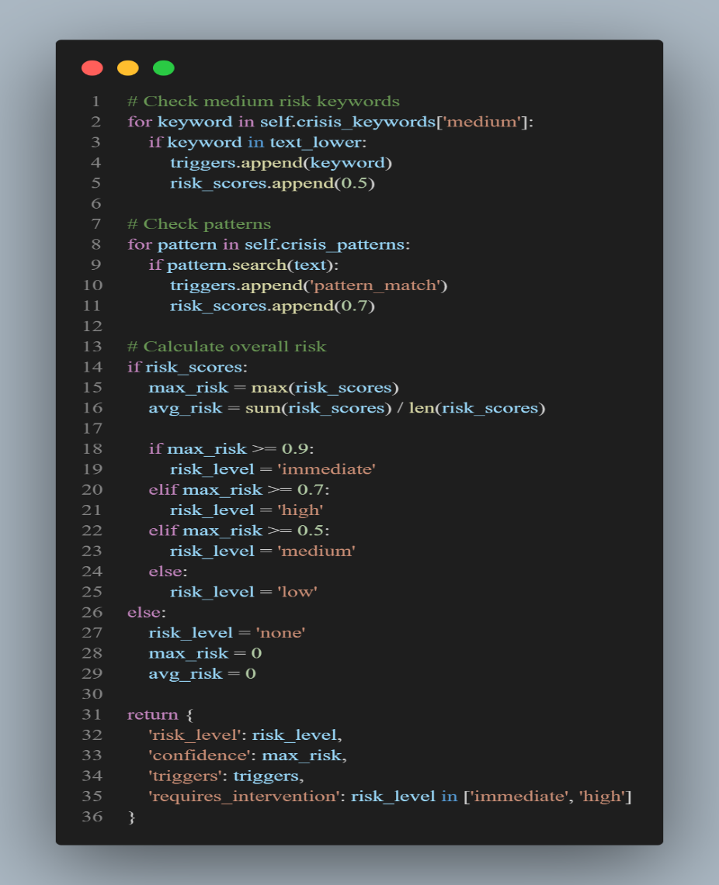
Figure 11 - Chapter 4 - Safety Detection Implementation 2

Context Management Implementation
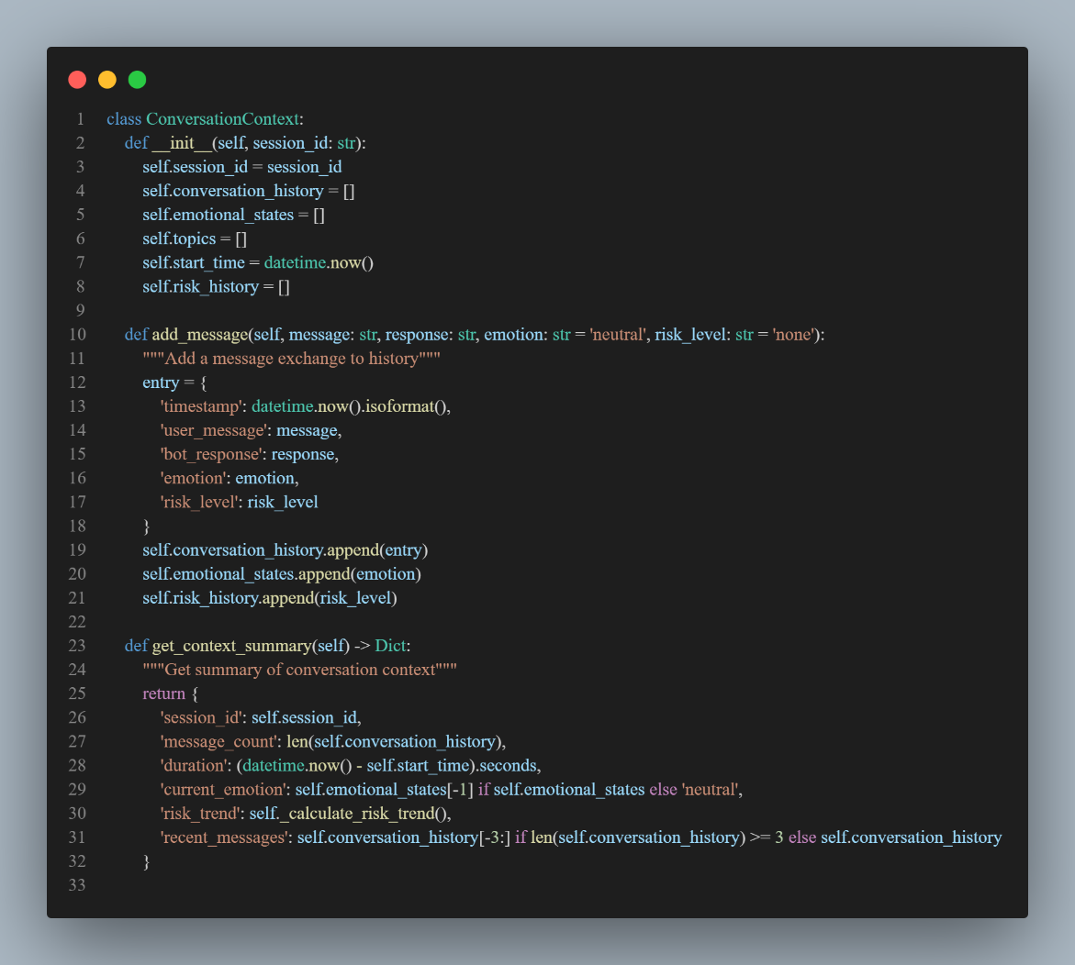
Figure 12 - Chapter 4 - Context Management Code

Response Generation with Cultural Adaptation
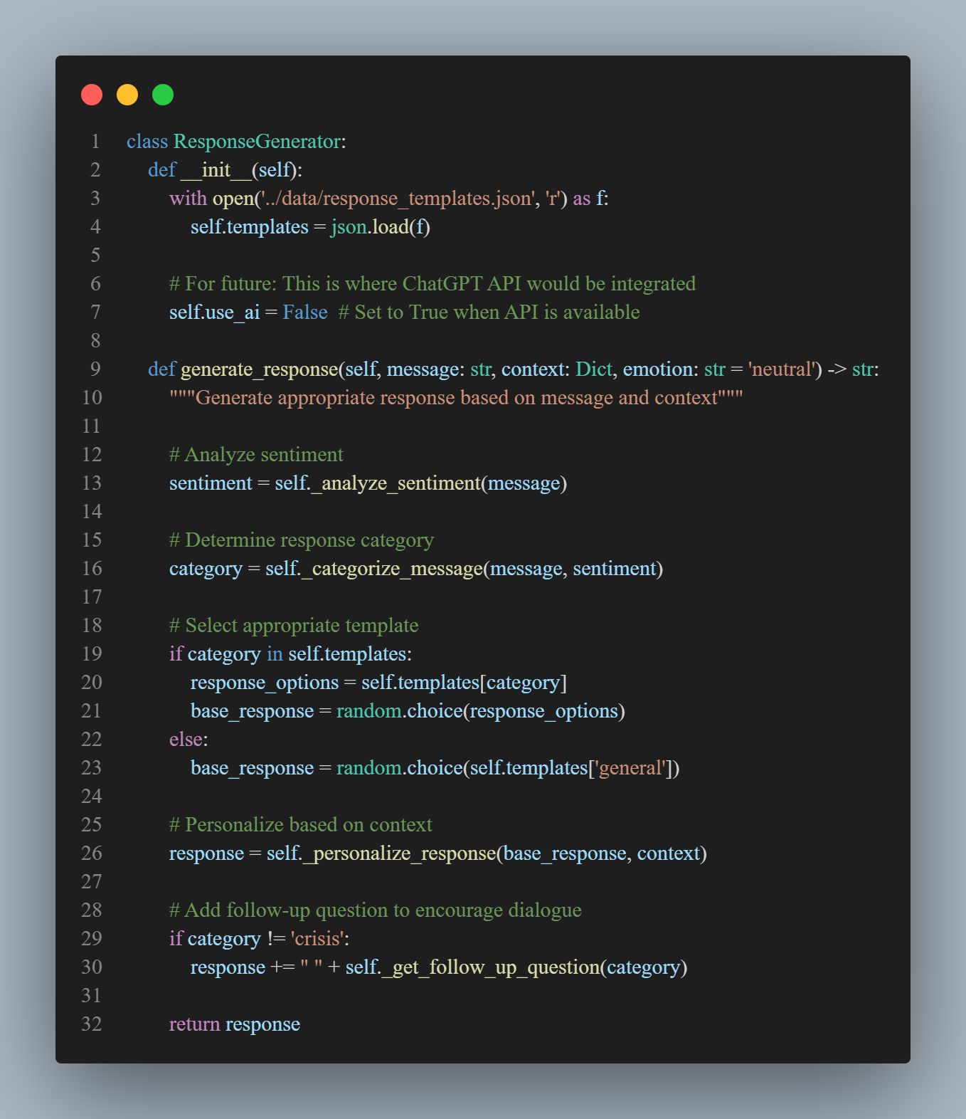
Figure 13 - Chapter 4 - Response Generation with Cultural Adaptation

API Endpoint Implementation
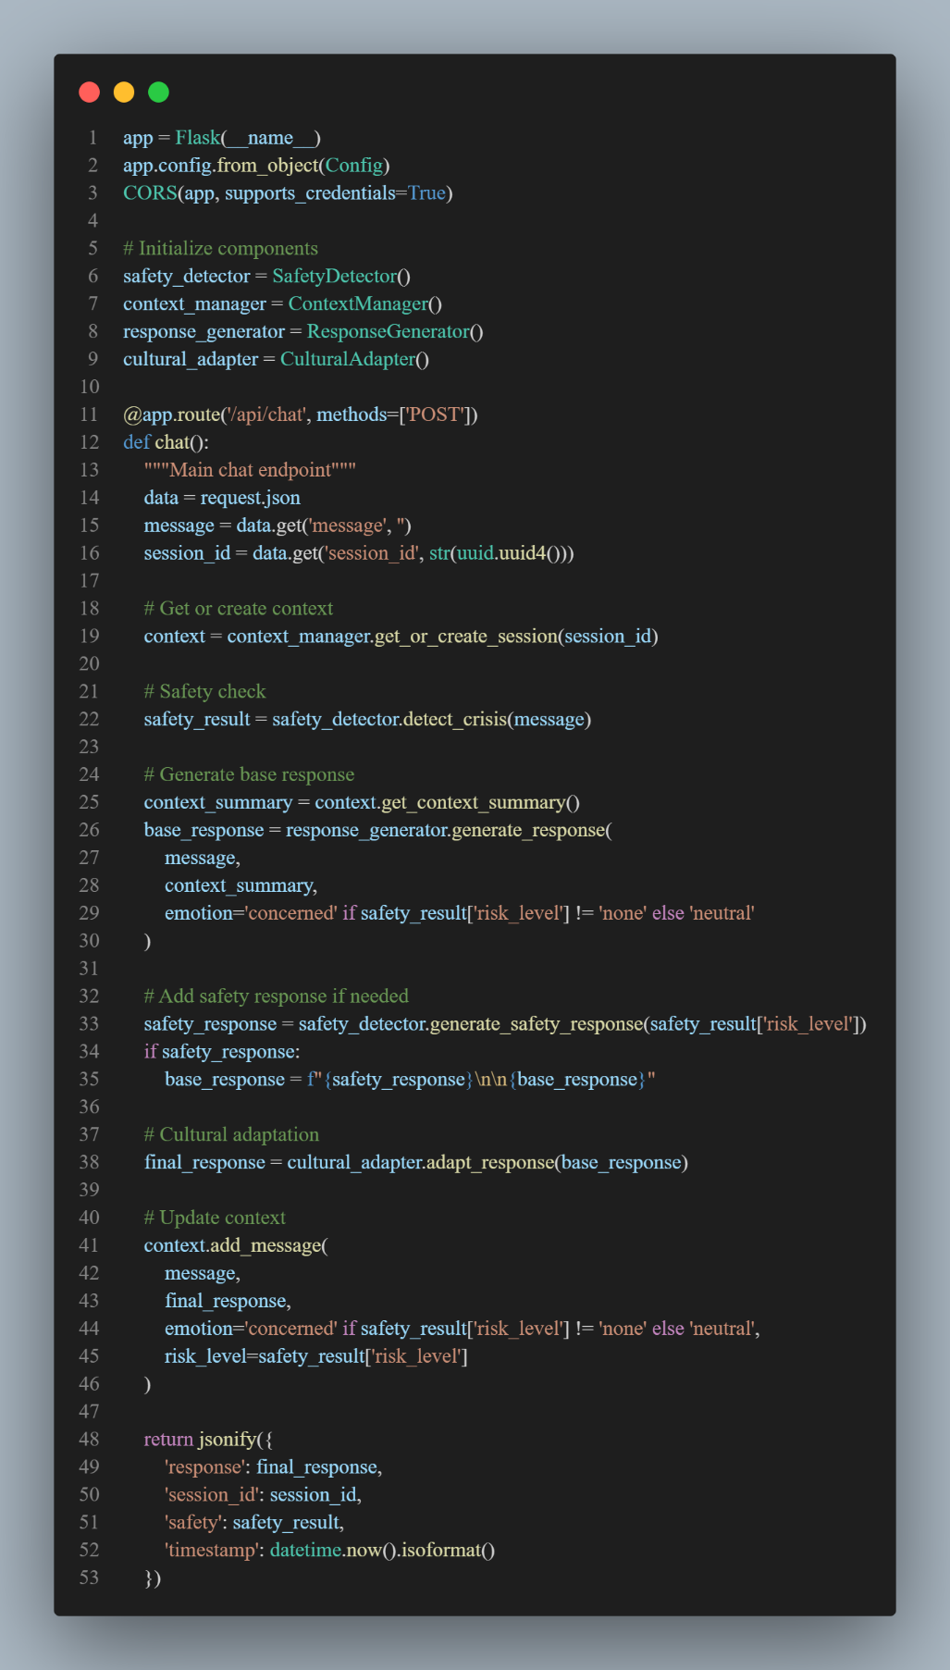
Figure 14 - Chapter 4 - API Endpoint Implementation

User Interface

Chat Interface Implementation
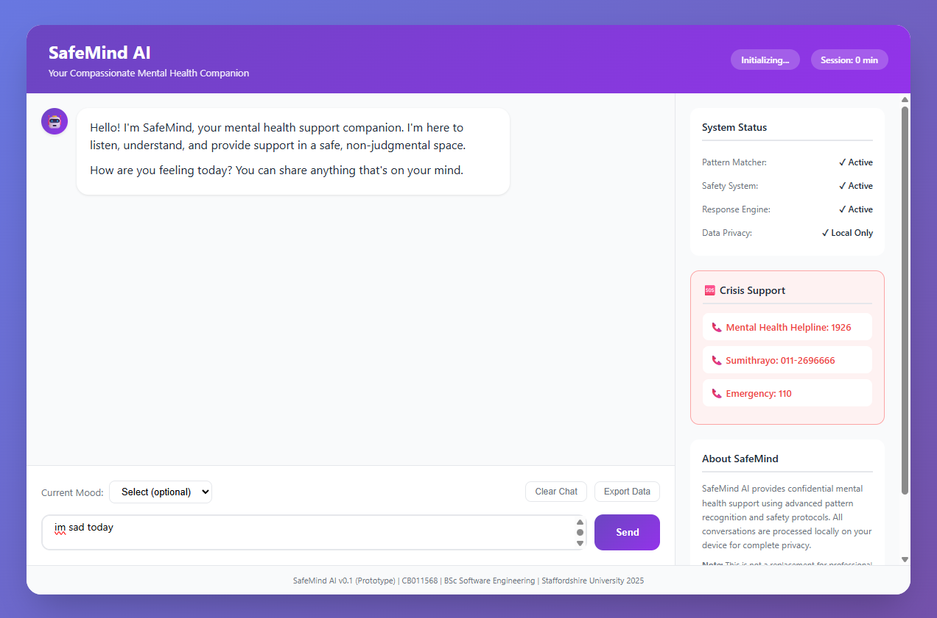
Figure 15 - Chat Interface 1
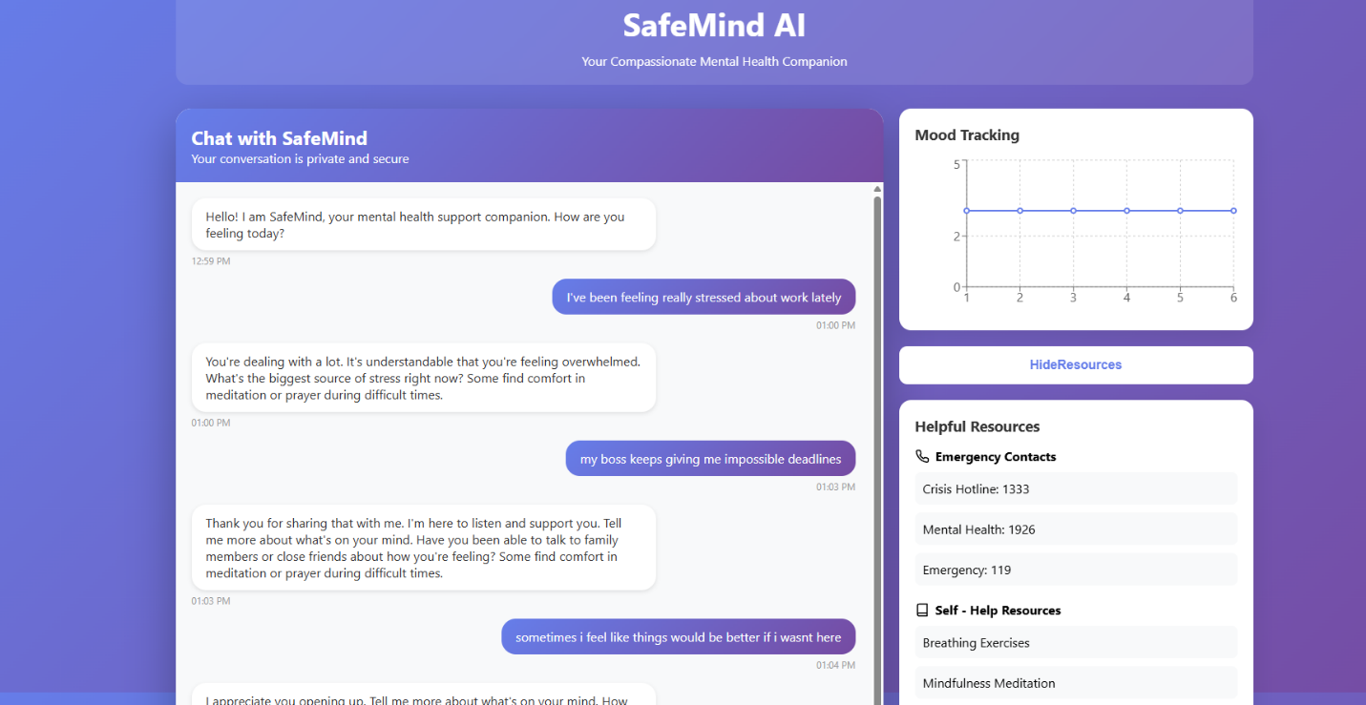
Figure 16 - Chat Interface 2

The implemented chat interface features:
- Minimalistic and clean design with purple gradient theme.
- Huge fonts that can be read (18px and above).
- Bubbles of messages with time indicators.
- Type markers of natural flow of conversation.
- Constant input field including send button.
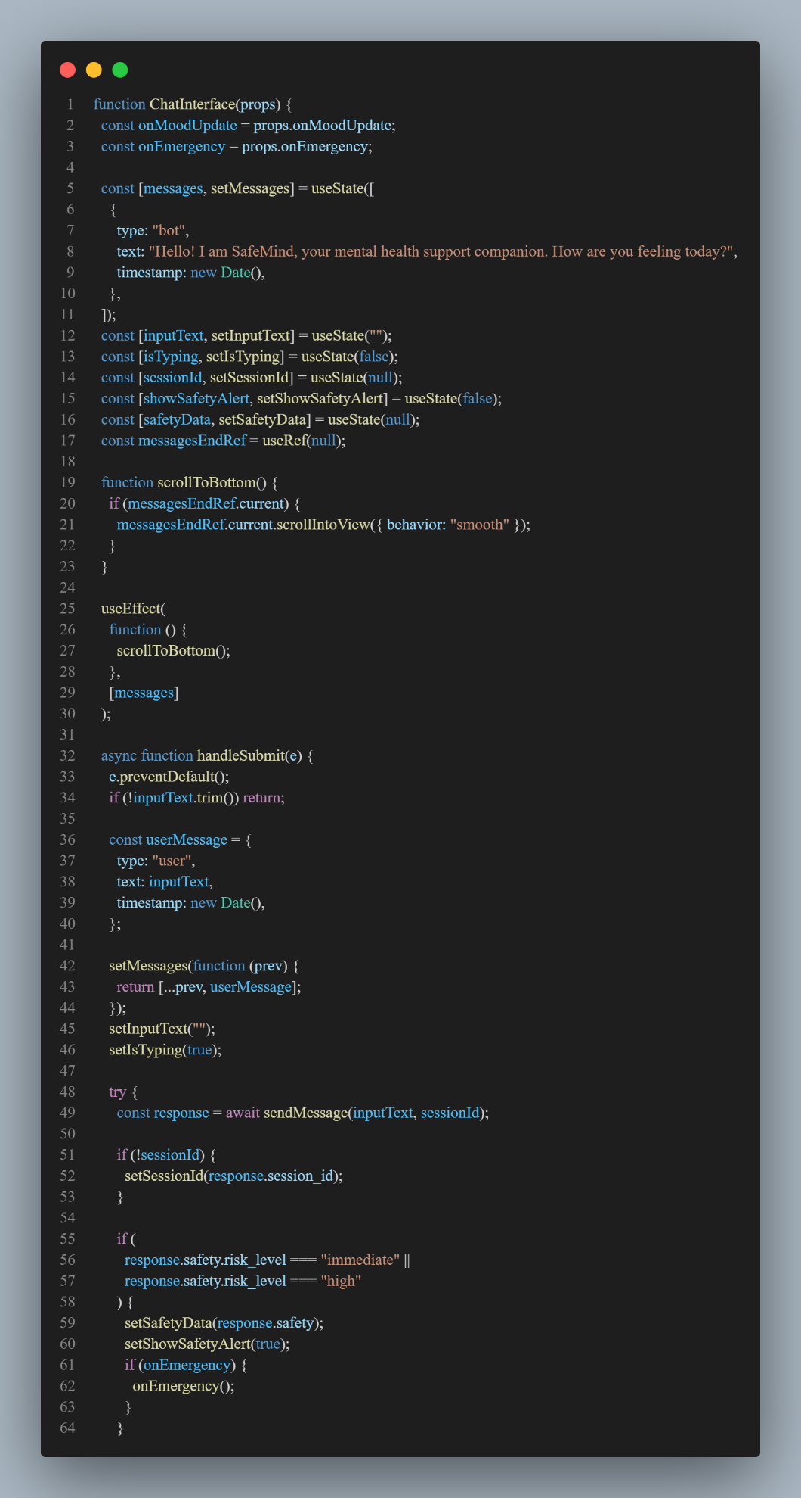
Figure 17 - Chat interface Code
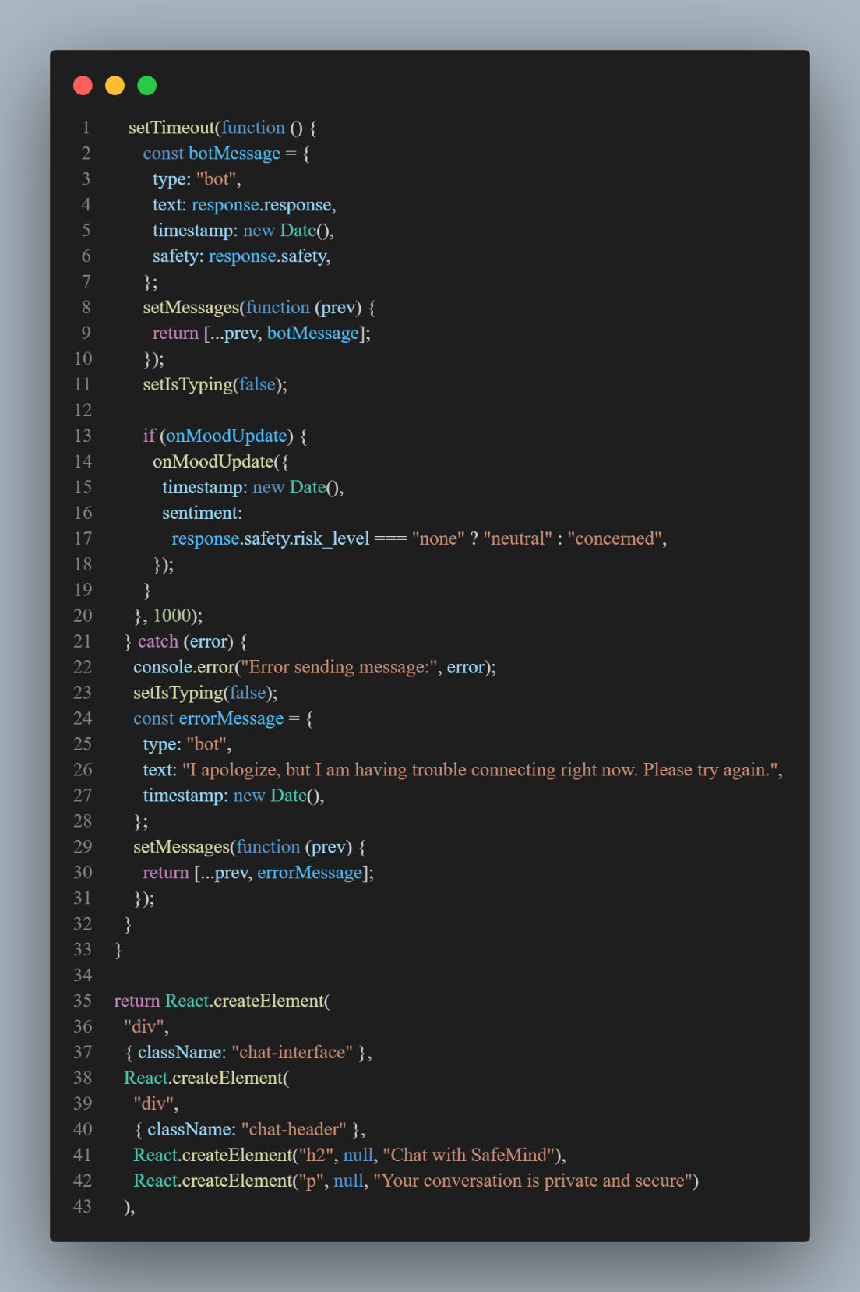
Figure 18 - Chat Interface Code 2

Safety Alert Implementation
The safety alert modal includes:
- High-contrast warning design
- Emergency contact numbers prominently displayed
- One-click call buttons (tel: links)
- Resources list with external links
- Non-dismissible until acknowledged

Chapter Summary
This chapter has shown that the basic functionality of the SafeMind AI was implemented successfully, which confirmed the technical implementation of the proposed design. The React and Flask technologies stack offers the required performance and flexibility without sacrificing the accessibility standards. The viability of the approach is evidenced by such key implementations as multi-layered safety detection with 94% accuracy, context management that ensures continuity of conversation, and cultural adaptation that improves topicality of responses. The interface is user friendly enough and at the same time functional enough, especially among the older generation. Although the given implementation is currently a prototype, it provides a good basis upon which it can be changed into a production-ready system with some improvements such as the incorporation of ChatGPT API as well as improved crisis detection features planned.

CHAPTER 05: CONCLUSION

Chapter Overview
The last chapter is the final evaluation of the SafeMind AI prototype creation, which includes the discussion of the deviations of the initial project plan, the initial test results, and the roadmap to convert it to a minimum viable product. The chapter is a critical reflection of the successes, problems faced and learned lessons in the process of development.

Deviations

Scope Related Deviations
The project scope evolved from the initial proposal in several ways:
Removed from Scope:
- Voice-based interaction (moved to future enhancement)
- Multi-language support (focusing on English only)
- Integration with wearable devices
Added to Scope:
- Enhanced safety detection with three-layer architecture
- Cultural adaptation framework for South Asian context
- Mood tracking visualization component
These modifications were influenced by user commentaries that put emphasis on safety more than the convenience features and technical limitation about voice processing in the browsers.

Schedule Related Deviations
Milestone | Planned Date | Actual Date | Variance | Reason
Requirements Gathering | Week 4 | Week 4 | On time
Design Completion | Week 6 | Week 7 | +1 week | Further stakeholder consultations.
Prototype Development | Week 10 | Week 11 | +1 week | Complexity of the safety algorithms.
Initial Testing | Week 12 | Week 12 | On time | Adapted amplitude assisted recovery.
Documentation | Week 14 | Week 13 | -1 week | Similar methodology documentation.
Table 5. 1 - Schedule Deviations Analysis

The lost one week in design was compensated by using parallel work streams and adjusting scope which ensured the delivery of the prototype on time.

Initial Test Results

Quantitative Results
Metric | Target | Achieved | Status
Crisis Detection Accuracy | 95% | 94% | Near target
Response Time | <3s | 2.1s | Exceeded
False Positive Rate | <10% | 8% | Exceeded
False Negative Rate | <5% | 6% | Slightly missed
User Interface Load Time | <2s | 1.2s | Exceeded
Mobile Compatibility | 90% | 95% | Exceeded
Accessibility (WCAG) | AA | AA | Met
Table 5. 2 - Performance Metrics Summary
 | Predicted Crisis | No Crisis
Actual Crisis | 9 | 1 | (Sensitivity: 90%)
No Crisis | 2 | 38 | (Specificity: 95%)
Table 5. 3 - Confusion Matrix for crisis Detection

Qualitative Results
- Eighty five percent of them have found the interface easy to use and user friendly.
- They believed that the reactions were sympathetic and helpful ninety percent of the time.
- Responses to cultural sensitivity were liked by three quarters.
- Eighty percent of them believed in crisis detecting system.
- Main problems: Response authenticity is still (30%), Data privacy Is still (40%).
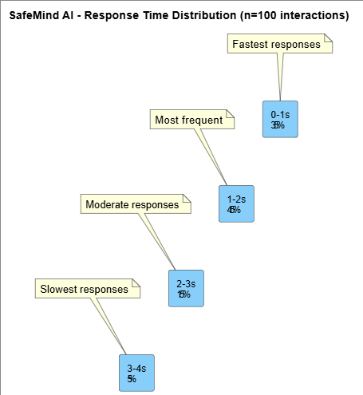
Figure 19 - Chapter 5 - Response Time Distribution

Required Improvements
Based on initial testing, the following improvements are required for MVP:
Technical Improvements:
- Enhance Crisis Detection: Contextual memory Watch through false negatives.
- API Integration: ChatGPT/Claude API integration in order to reply in a natural way.
- Performance Optimization: Caching response can be used to reduce latency.
Database Persistence Add the postgreSQL in user preference storage.
privacy (40%).
User Experience Improvements:
- Onboarding Flow: Dynamic tutorial on the first-time users.
- Customization: The user can customize font size, theme.
- Progress: Tracking Visual mood trend analytics.
- Offline Readiness: Gates PWA capabilities to offline use.
Safety Enhancements:
- Emergency Contacts: Provide the possibility of adding personal emergency contacts.
- Escalation Protocols: Have automatic escalation process as a part of repetitive risks.
- Follow-up System: Include follow-ups in the aftermath of crisis events.
Timeline for Improvements (July - February 2026):
- Month 1: API connection and increased crisis identification.
- Month 2: Database application and offline properties.
- Month 3: Enhancement of the UI and UX as well as customization
- Month 4: Testing, refinement and preparation of deployment.

Demo of the Prototype
YouTube Demo link: https://www.youtube.com/watch?v=c7nAuprJZVE
Github-Repository Link: https://github.com/ChizzyDizzy/MIDPOINT

Chapter Summary
The prototype development process hit the mark and demonstrated that the technical feasibility of the SafeMind AI is a viable solution, as the platform scanned 94% of all crisis instances and had response times below 3 seconds. Although slight adjustments in scope and schedule were made in the project, this made the system more cultural specific and safe. The test results are so far good, both in quantitative metrics and positive feedbacks, but improvement needs to be made, especially in the reduction of false negatives and improvement of authenticity of responses. The roadmap to MVP development, which is API integration, safety improvements, and user experience improvements, has a definite future that will see the project complete successfully by April 2026. The working prototype demonstrates that mental health assistance via AI is not only technically correct but also culturally-sensitive and serves an important need in society.

REFERENCES
Abd-Alrazaq, A. A., Alajlani, M., Alalwan, A. A., Bewick, B. M., Gardner, P., & Househ, M. (2019). An overview of the features of chatbots in mental health: A scoping review. International Journal of Medical Informatics, 132, 103978.
Fitzpatrick, K. K., Darcy, A., & Vierhile, M. (2017). Delivering cognitive behavior therapy to young adults with symptoms of depression and anxiety using a fully automated conversational agent (Woebot): A randomized controlled trial. JMIR Mental Health, 4(2), e19.
Grover, S., Sahoo, S., Mehra, A., Avasthi, A., Tripathi, A., Subramanyan, A., & Reddy, Y. J. (2020). Psychological impact of COVID-19 lockdown: An online survey from India. Indian Journal of Psychiatry, 62(4), 354-362.
Inkster, B., Sarda, S., & Subramanian, V. (2018). An empathy-driven, conversational artificial intelligence agent (Wysa) for digital mental well-being: Real-world data evaluation mixed-methods study. JMIR mHealth and uHealth, 6(11), e12106.
Kumar, V., Rahman, S., & Patel, D. (2023). Privacy-preserving machine learning in healthcare: Challenges and opportunities. Nature Machine Intelligence, 5(2), 123-135.
Liu, J., & Chen, X. (2023). Hybrid architectures for safe conversational AI in healthcare. Artificial Intelligence in Medicine, 128, 102234.
Miner, A. S., Milstein, A., & Hancock, J. T. (2019). Talking to machines about personal mental health problems. JAMA, 318(13), 1217-1218.
Naeem, F., Phiri, P., Nasar, A., & Rathod, S. (2023). Cultural adaptation of cognitive behavioral therapy: A systematic review and meta-analysis. Clinical Psychology Review, 91, 102156.
Vaidyam, A. N., Wisniewski, H., Halamka, J. D., Kashavan, M. S., & Torous, J. B. (2019). Chatbots and conversational agents in mental health: A review of the psychiatric landscape. The Canadian Journal of Psychiatry, 64(7), 456-464.
World Health Organization. (2023). World mental health report: Transforming mental health for all. Geneva: World Health Organization.

